

FACULTY OF ENGINEERING & TECHNOLOGY

ASSIGNMENT 3 REPORT OF COMPUTER PROGRAMMNIG USING MATLAB

PRESENTED TO
THE COMPUTER PROGRAMMING COURSE LECTURER
MR. MASERUKA BENDICTO

By GROUP 8 BEM

GROUP MEMBERS
NAMES | REG NUMBER | PROGRAM
ENYUKU PIUS | BU/UP/2025/4638 | BEM
MUGUSHA JOB | BU/UP/2025/05719 | BEM
RUBANGAKENE JONATHAN | BU/UP/2025/1994 | BEM
KISOLO OWEN SAM | BU/UP/2025/05873 | BEM
HAFIZAH KHADIJAH MUSA | BU/UP/2025/4608 | BEM

ABSTRACT
This report details a two-part MATLAB assignment focused on applying data handling and organization skills building from assignment one as we studied from module one to four during lecture time.
From question one of assignment one, we were to use that data to visualize the parameters, patterns trends and relationships saving the 2D plot as an image and label it

ACKNOWLEGEMENT
We thank God Almighty for the gift of life, love and wisdom throughout this course.
Also our gratitude goes to our course lecturer, Mr. Maseruka Bendicto for guiding us in this course that is a necessity in our engineering professions.
And lastly, appreciation goes to all our group members for the commitment and team spirit which simplified work and made it easy for us to complete the task and come up with this report.

DECLARATION
We, Group 8 members hereby declare that report is to the best of our knowledge and has been developed and written by us. It includes the details of the assignment and it has never been presented by any individual.
Group 8

NAMES | REG NUMBER | PROGRAM
ENYUKU PIUS | BU/UP/2025/4638 | BEM
MUGUSHA JOB | BU/UP/2025/05719 | BEM
RUBANGAKENE JONATHAN | BU/UP/2025/1994 | BEM
KISOLO OWEN SAM | BU/UP/2025/05873 | BEM
HAFIZAH KHADIJAH MUSA | BU/UP/2025/4608 | BEM

APPROVAL
This is to confirm that this report has been written and presented by Group 8, giving details of the assignment carried out.
Name ..............................................................................................................
Date ..................................................................................................................
Signature ........................................................................................................

TABLE OF CONENT

ABSTRACT 3
ACKNOWLEGEMENT 4
DECLARATION 5
APPROVAL 6
Introduction 6
Chapter 2: SOLUTIONS 7
From question one 1: 7
Using the Dataset 7
Methodology 7
Chapter 3: 16
Conclusion and Learning Experience 16
Chapter 4: 18
References and Resources 18

Introduction
This report gives a detailed overview of the MATLAB assignment built from the questions of assignment three showing use of the different MATLAB features from module one to module four. The exercise focused on data input and output , specifically the process of inputing a dataset , structuring it for analysis, and importing from organized Excel workbook and plot 2D plots.
From question 1;
- Utilize all the knowledge obtained from module one to three to visualize the different parameters, patterns, trends and relationships.
- Ensure that each 2D plot is saved as an image its well labelled.

Chapter 2: SOLUTIONS

From question one 1:

Using the Dataset
The primary objective of this exercise was to create a MATLAB script suitable for handling an external dataset. Our approach was a three-step process:

Methodology
Data Acquisition and processing
Using the already cleaned dataset; Indian-Water data that we had used in the first assignment that was obtained from data inform of excel workbook.
Our task was to come up with a MATLAB code that would return different skills as required.
Below is a list of the different skills we were able to apply in question one
- Data input
- Importing data
- 2D plotting
Below is a code that returns all the above skills.
ourgroup = readtable('C:\Users\piuse\OneDrive\Desktop\group work\GROUP 8.xlsx')
data = readtable('C:\Users\piuse\OneDrive\Desktop\group work\GROUP 8.xlsx')
x = data.CPA;
y = data.GPA;
plot(x, y);
xlabel('CPA');
ylabel('GPA');
title('line plot');
grid on;
x = data.CPA;
y = data.GPA;
scatter(x, y)
xlabel('cpa');
ylabel('gpa');
title('scatter plot');
grid on
x = data.FULLNAME;
y = data.GPA;
bar(x, y);
ylabel('gpa');
title('bar graph');
grid on
y = data.GROUPNUMBER;
barh(y)
xlabel('cpa');
title('horizontal bar graph');
grid on
x = data.GROUPNUMBER;
y = sin(x);
stem(x, y)
xlabel('group number');
ylabel(' sin()');
title('stem plot');
grid on
x = data.GROUPNUMBER;
y = sin(x);
stairs(x, y);
xlabel('x');
ylabel(' sin(x)');
title('step plot');
grid on
x = data.GROUPNUMBER;
y = 10 + randn(1,5);
errors = rand(1,5);
errorbar(x,y,errors)
xlabel('x');
ylabel('y');
title('error bar plot');
grid on
x = data.GROUPNUMBER;
y = sin(x);
area(x, y);
xlabel('x');
ylabel(' sin(x)');
title('area plot');
grid on
histogram(data.GPA);
xlabel('gpa');
ylabel(' count')
title('histogram of gpa');
grid on
pareto(data.GROUPNUMBER);
title('pareto chart')
boxplot(data.CPA);
title('Box plot');
grid on
pie(data.GROUPNUMBER);
title('pie chart')
labels ={'a','b','c','d','e'};
pie(data.GROUPNUMBER,labels);
title(' pie chart with percent labels')
x = data.GROUPNUMBER;
y = exp(x);
semilogx(x,y);
THE FIGURES BELOW SHOWS SOME OF OUR 2D PLOTS

 | FULLNAME | REGNO | TRIBE | RESIDENCE | FRIENDS | AGE | GROUPNAME | GROUPNUMBER | GPA | CPA
1 | 'ENYUKU PIUS' | 'BU/UP/2025/4638' | 'ATESO' | 'HOSTEL' | 'ANSHE' | 21 | 'ONE' | 1 | 3.9800 | 3.7800
2 | 'MUGUSHA JOB' | 'BU/UP/2025/05719' | 'BUGANDA' | 'HOSTEL' | 'MARK' | 22 | 'TWO' | 2 | 3.5600 | 3.5600
3 | 'RUBANGAKENE JONATHAN' | 'BU/UP/2025/994' | 'LUO' | 'HOSTEL' | 'STEVE' | 21 | 'THREE' | 3 | 3.5500 | 3.6700
4 | 'KISOLO OWEN SAM' | 'BU/UP/2025/05873' | 'BUGANDA' | 'HOSTEL' | 'MARK' | 22 | 'FOUR' | 4 | 3.8900 | 3.7800
5 | 'HAFIZAH KHADIJAH MUSA' | 'BU/UP/2025/4608' | 'ACHOL' | 'HALL' | 'HANNAH' | 21 | 'FIVE' | 5 | 3.7800 | 3.4500
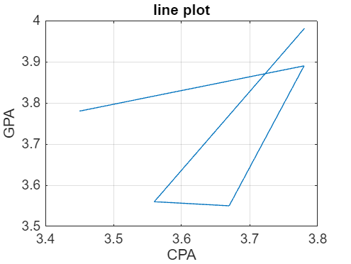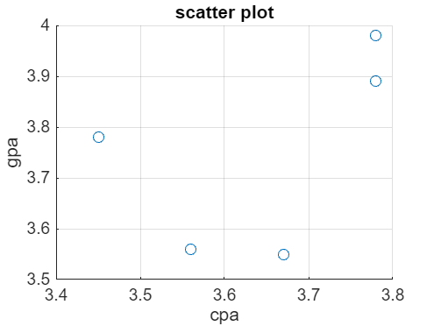

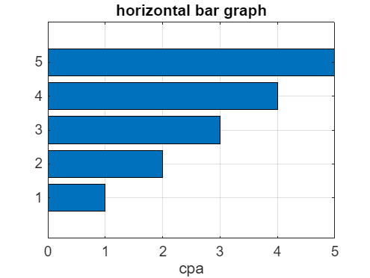
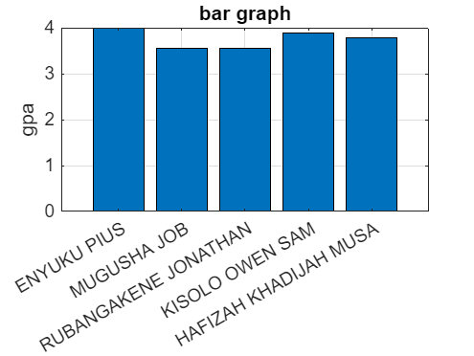

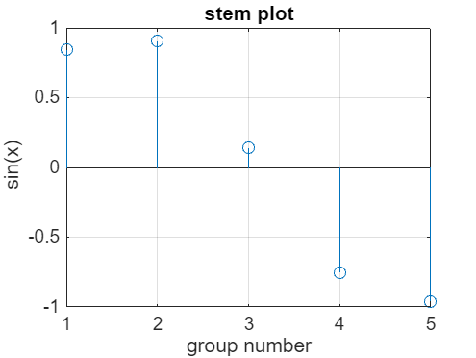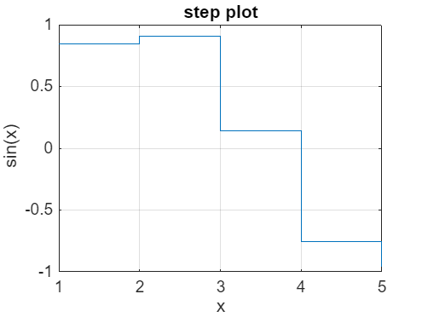
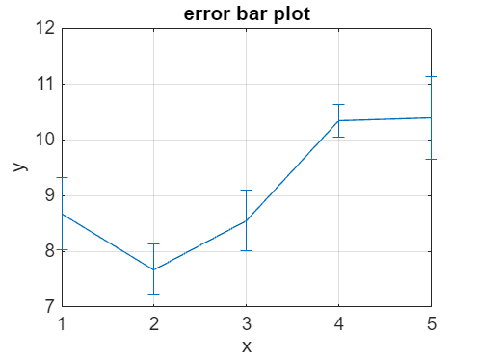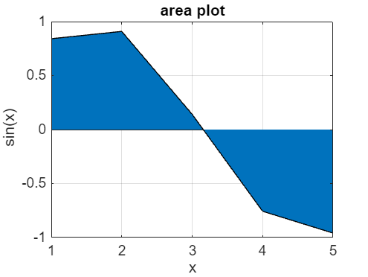

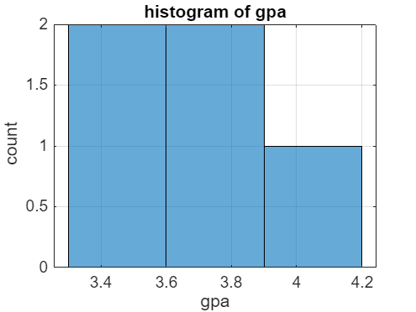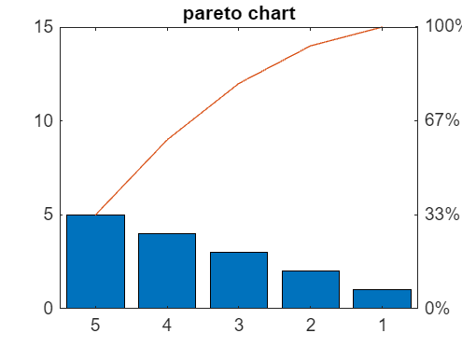

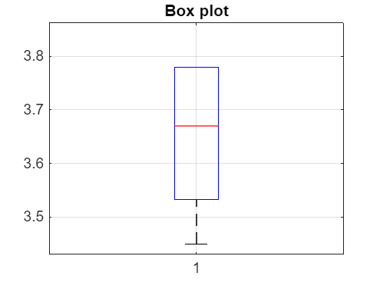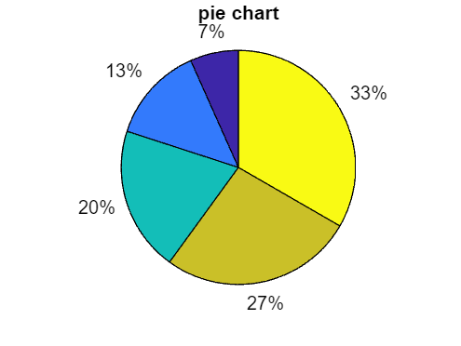

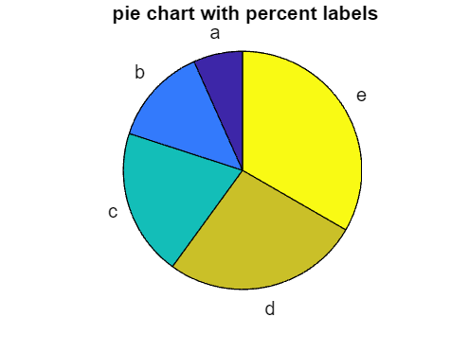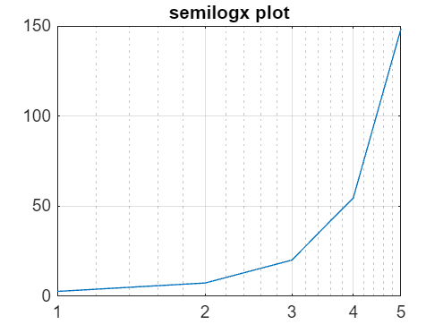

Chapter 3:

Conclusion and Learning Experience

This assignment has helped us to acquire knowledge and experience that helped us understand MATLAB programming concepts and gave us experience with the foundations we had acquired from Modules one to four. We also understood how to handle real-world data given we used the Kaggle dataset.
Generally, this assignment provided a practical foundation in data management and problem-solving within a computing environment.

Chapter 4:

References and Resources
- MATLAB Documentation - Used for syntax and function guidance on readtable()
- Microsoft Excel Cleaning techniques from Microsoft community forums.
- Computer programming lecture notes.

